**PRACTICAL-1**

AIM : Study the different components of desktop computer and server (IBM 360) and assembling both of them.

SOLUTON :

* **CPU (Central Processing Unit)**

What is CPU? What components does the CPU have ? What are the functions of that components in CPU?

The central processing unit (CPU) is the unit, which performs most of the processing inside a computer. To control instructions and data flow to and from other parts of the computer, the CPU relies heavily on a chip set, which is a group of microchips located on the motherboard.

The CPU has two typical components:

* Control Unit: extracts instructions from memory and decodes and executes them.
* Arithmetic Logic Unit (ALU): handles arithmetic and logical operations.

To function properly, the CPU relies on the system clock, memory, secondary storage, and data and address buses.

This term is also known as a central processor, microprocessor or chip.

The CPU is the heart and brain of a computer. It receives data input, executes instructions, and processes information. It communicates with Input/Output (I/O) devices, which send and receive data to and from the CPU. Additionally, the CPU has an internal bus for communication with the internal cache memory, called the backside bus. The main bus for data transfer to and from the CPU, memory, chipset, and AGP socket is called the front side bus.

CPU contains internal memory units, which are called registers. These registers contain data, instructions, counters, and addresses used in the ALU information processing.

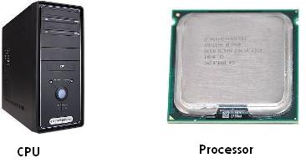

**CABINET**

Some computers have dual or multiple processors. These consist of two or more separate physical CPUs located side-by-side on the same board or on separate boards. Each CPU has an independent interface, separate cache, and individual paths to the system front-side bus. Multiple processors are ideal for intensive parallel tasks requiring multitasking.

The different components of the computer are as follows :

* Processor
* Main Memory
* Secondary Memory
* Monitor
* Keyboard
* Mouse

Now inside the case ,the hardware part contains of :

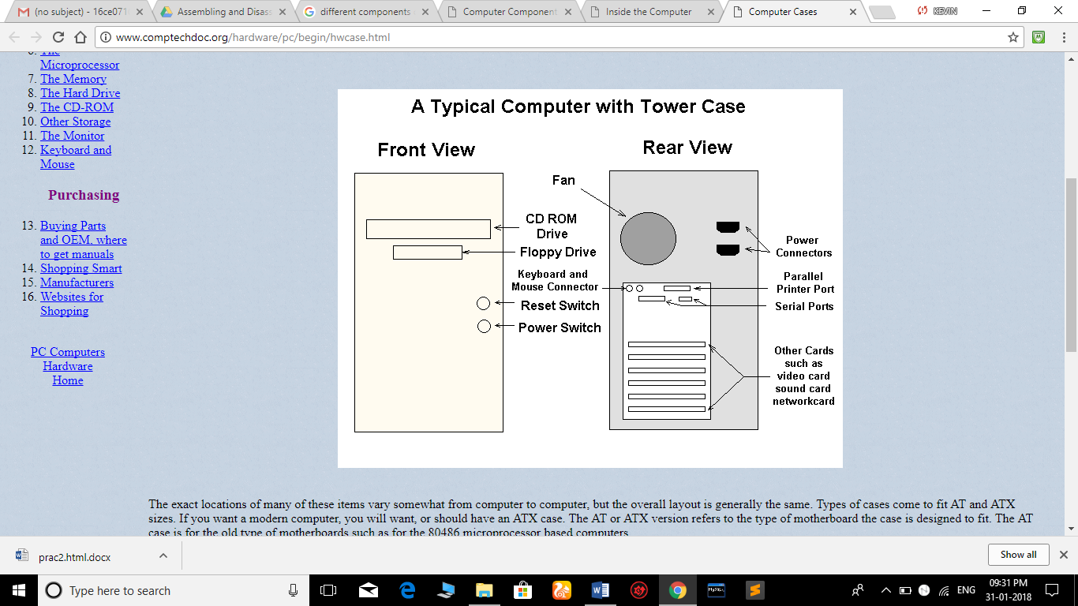

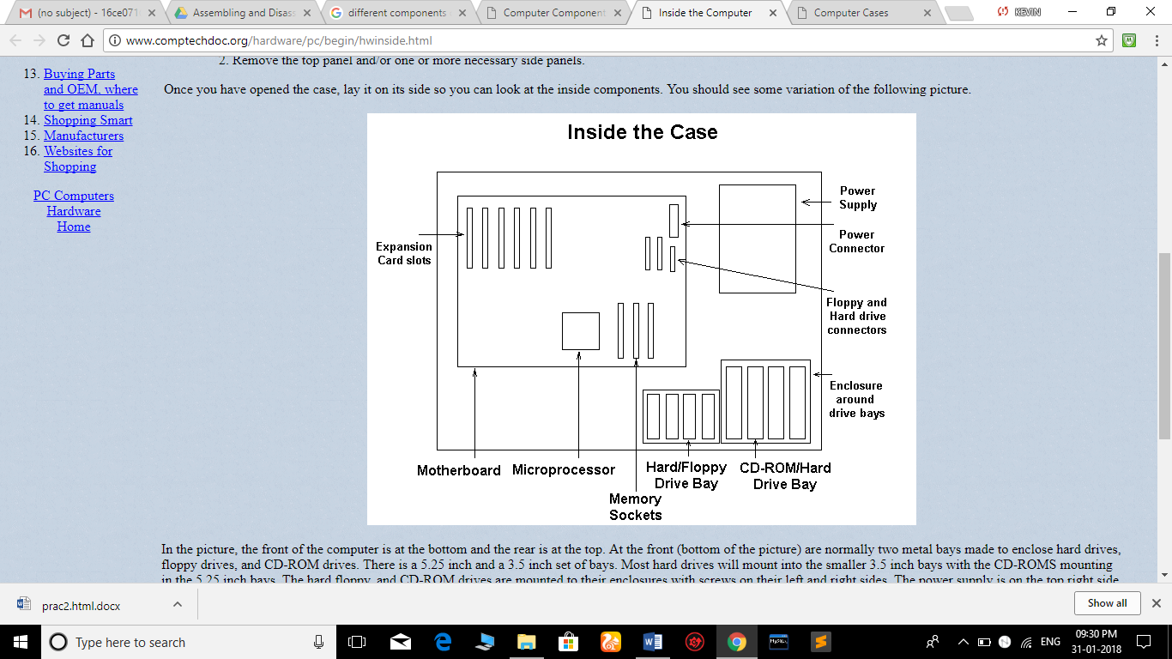

DIFFERENT COMPONENTS OF MOTHERBOARD

* MOTHERBOARD

The main printed circuit board in a computer is known as the motherboard. Other names for this central computer unit are system board, main board, or printed wired board (PWB).

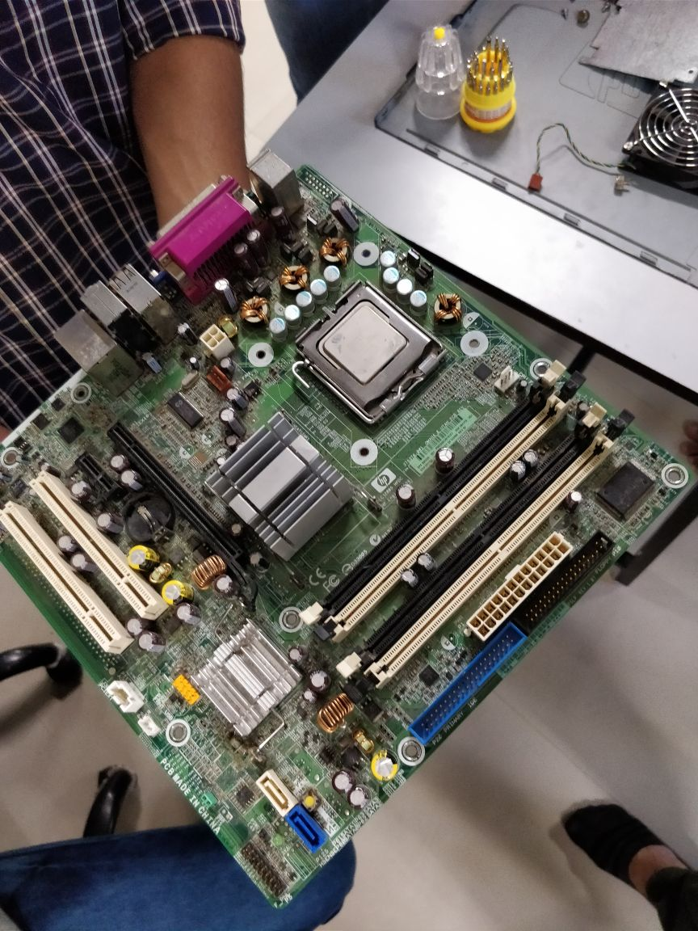

* Processor

A processor is the logic circuitry that responds to and processes the basic [instructions](http://whatis.techtarget.com/definition/instruction) that drive a computer.

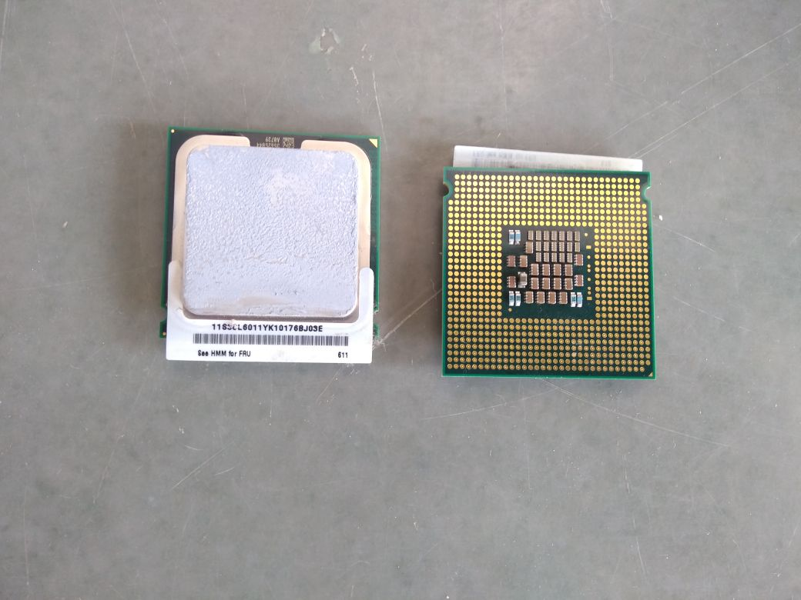

There are different types of processors like intel i3,i5,i7 and it has also different ranges in them.

* Memory Slots

A memory slot, memory socket, or RAM slot is what allows computer memory ([RAM](https://www.computerhope.com/jargon/r/ram.htm)) to be inserted into the computer. Depending on the [motherboard](https://www.computerhope.com/jargon/m/mothboar.htm), there may be two to four memory slots (sometimes more on high-end motherboards) and are what determine the type of RAM used with the computer. The most common types of RAM are [SDRAM](https://www.computerhope.com/jargon/s/sdram.htm) and [DDR](https://www.computerhope.com/jargon/d/ddr.htm) for desktop computers and [SODIMM](https://www.computerhope.com/jargon/d/dimm.htm) for [laptop](https://www.computerhope.com/jargon/l/laptop.htm) computers, each having various types and speeds.

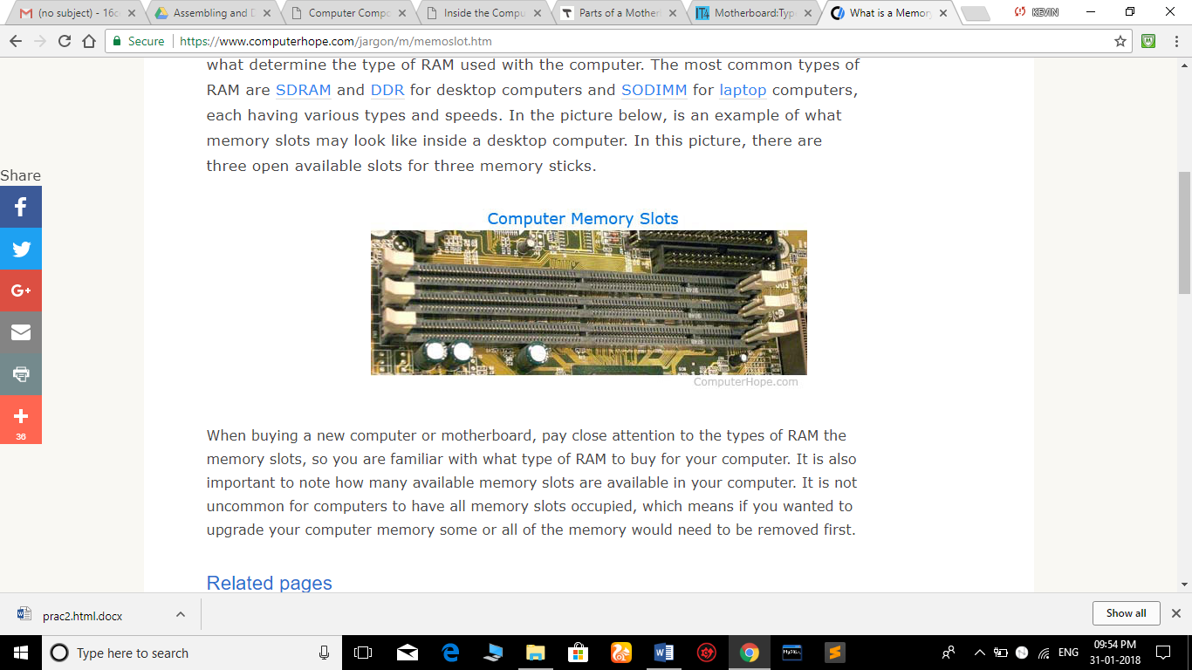

* RAM (Random Access Memory)

Random Access Memory, or RAM, usually refers to computer chips that temporarily store dynamic data to enhance computer performance while you are working. Random access memory is volatile, meaning it loses its contents once power is turned off.

There are different type of RAM like DDR,DDR2,DDR3,DDR4.

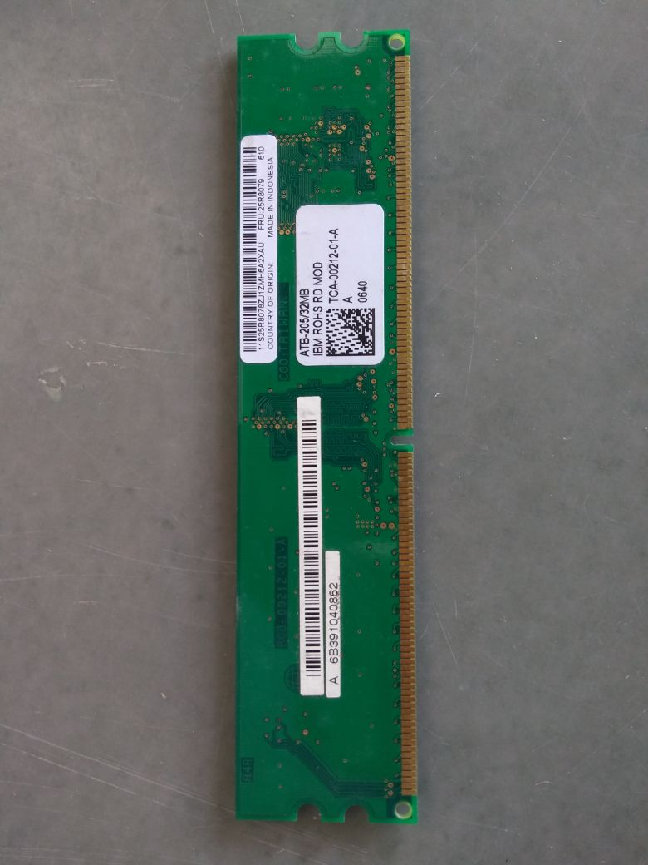

* BIOS( Basic Input/Output System)

BIOS stands for Basic Input/Output System. BIOS is a "read only" memory, which consists of low-level software that controls the system hardware and acts as an interface between the operating system and the hardware.

* CMOS RAM(Complimentary Metal Oxide Semiconductor RAM)

Motherboards also include a small separate block of memory made from CMOS RAM chips which is kept alive by a battery (known as a CMOS battery) even when the PC’s power is off.

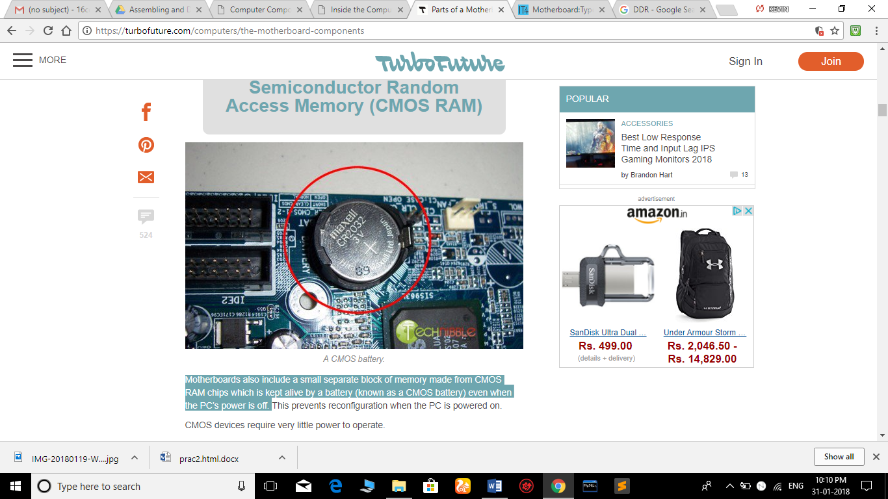

* EXPANSION BUS OR PCI SLOT

An expansion bus is an input/output pathway from the CPU to peripheral devices and it is typically made up of a series of slots on the motherboard. Expansion boards (cards) plug into the bus.

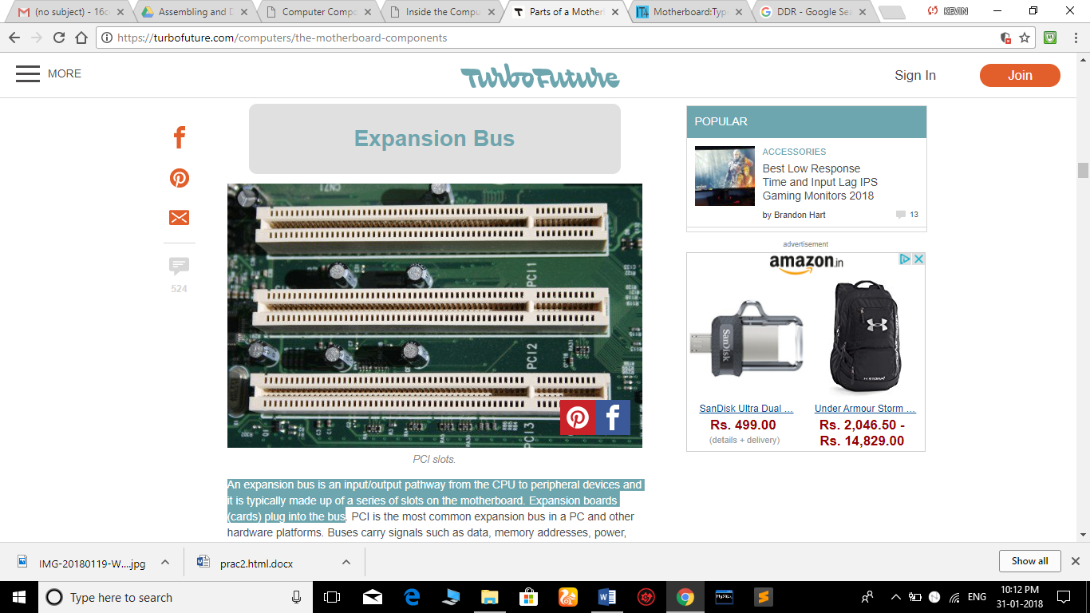

* CABINET CONNECTIONS

The cabinet in which the motherboard is installed has many buttons that connect to the motherboard. Some of the common connectors are Power Switch, Reset Switch, Front [USB](http://www.it4nextgen.com/usb-connectors-definition-types-compatibility/), Front Audio, Power indicator(LED) and HDD LED.

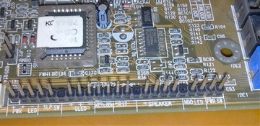

* SMPS

A switched-mode power supply (switching-mode power supply, switch-mode power supply, switched power supply, SMPS, or switcher) is an electronic [power supply](https://en.wikipedia.org/wiki/Power_supply) that incorporates a [switching regulator](https://en.wikipedia.org/wiki/Voltage_regulator#Switching_regulators) to [convert electrical power](https://en.wikipedia.org/wiki/Electrical_power_conversion) efficiently. Like other power supplies, an SMPS transfers power from a DC or AC source (often [mains power](https://en.wikipedia.org/wiki/Mains_electricity)) to DC loads, such as a [personal computer](https://en.wikipedia.org/wiki/Personal_computer), while converting voltage and current characteristics.

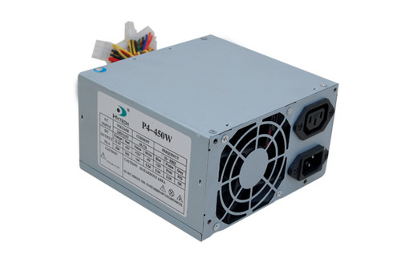

* AGP Slot(Accelerated Graphics Port)

The Accelerated Graphics Port (AGP) is a high-speed point-to-point channel for attaching a [video card](https://en.wikipedia.org/wiki/Video_card) to a [computer](https://en.wikipedia.org/wiki/Computer) system.

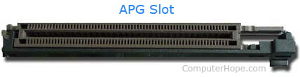

* CPU FAN AND HEAT SINK

A heat sink is an electronic [device](https://www.computerhope.com/jargon/d/device.htm) that incorporates a [fan](https://www.computerhope.com/jargon/f/fan.htm) to keep a hot component such as a [processor](https://www.computerhope.com/jargon/c/cpu.htm) cool.

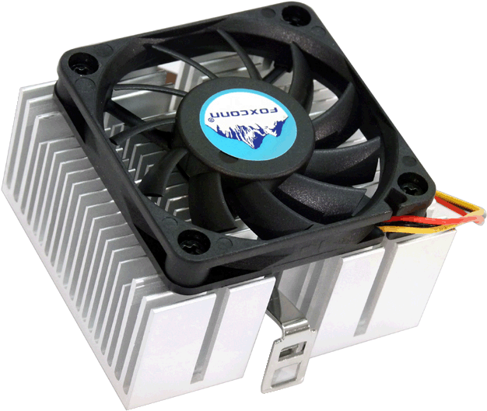

* NORTH BRIDGE AND SOUTH BRIDGE

The north bridge is responsible for accomplishing the task requiring high performance.eg. processor and RAM.Thats why it is located to near RAM and processor.

The southbridge typically implements the slower capabilities of the motherboard in a northbridge/southbridge [chipset](https://en.wikipedia.org/wiki/Chipset) computer architecture.

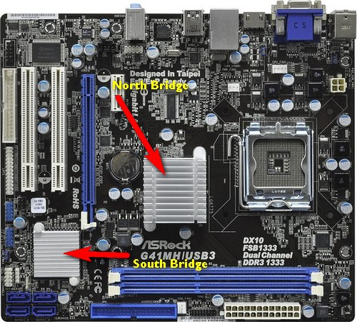

* HARD DISK

A hard disk drive (HDD), hard disk, hard drive or fixed disk[[b]](https://en.wikipedia.org/wiki/Hard_disk_drive#cite_note-3) is a [data storage device](https://en.wikipedia.org/wiki/Data_storage_device) that uses [magnetic storage](https://en.wikipedia.org/wiki/Magnetic_media) to store and retrieve [digital](https://en.wikipedia.org/wiki/Digital_data) information using one or more rigid rapidly rotating disks ([platters](https://en.wikipedia.org/wiki/Hard_disk_platter)) coated with magnetic material. The platters are paired with [magnetic heads](https://en.wikipedia.org/wiki/Disk_read-and-write_head), usually arranged on a moving [actuator](https://en.wikipedia.org/wiki/Actuator) arm, which read and write data to the platter surfaces.

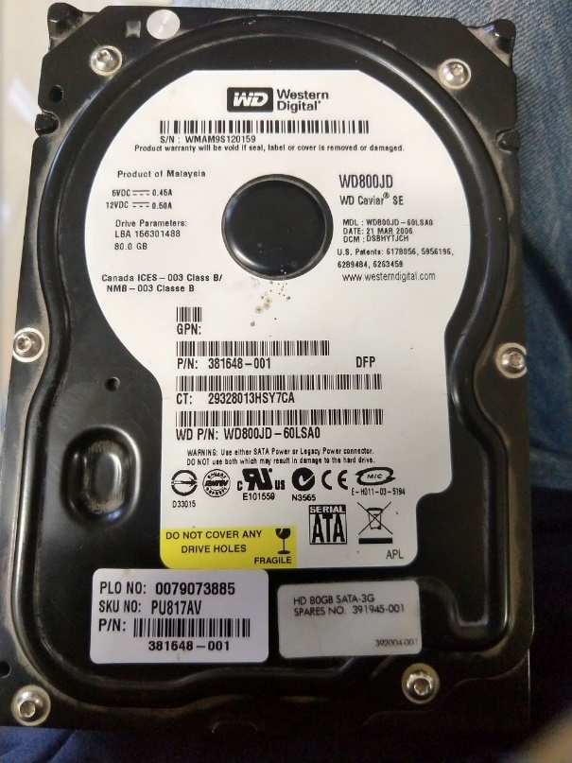

* CD/DVD DRIVE (Optical Disk Drive)

An optical disk drive (ODD) uses a laser light to read data from or write data to an optical disc. These include CDs, DVDs, and Blu-ray discs. This allows you to play music or watch movies using pre-recorded discs.

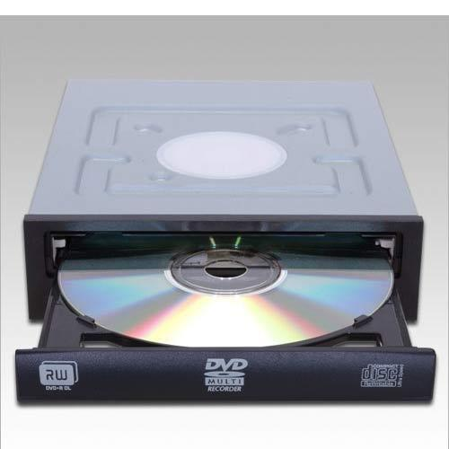

* FLOPPY DISK DRIVE

Floppy disks are read and written by a floppy disk drive (FDD). Floppy disks, initially as 8-inch (200 mm) media and later in 5¼-inch (133 mm) and 3½-inch (90 mm) sizes, were a ubiquitous form of data storage and exchange from the mid-1970s into the first years of the 21st century.

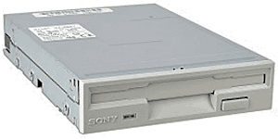

* GRAPHICS CARD OR VIDEO CARD

A video card (also called a display card, graphics card, display adapter or graphics adapter) is an [expansion card](https://en.wikipedia.org/wiki/Expansion_card) which generates a feed of output images to a display (such as a [computer monitor](https://en.wikipedia.org/wiki/Computer_monitor)) At the core of both is the processor unit [graphics processing unit](https://en.wikipedia.org/wiki/Graphics_processing_unit) (GPU), which is the main part that does the actual computations, but should not be confused as the video card as a whole.

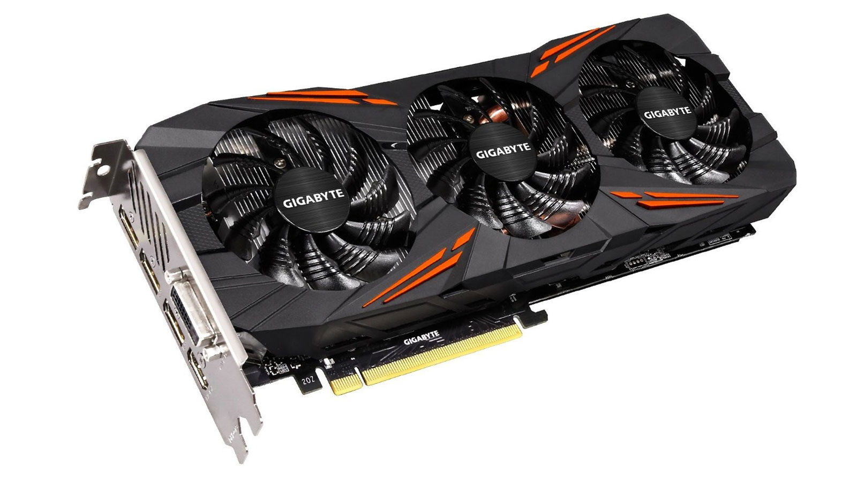

**STEPS TO ASSEMBLE A PC**

Step 1: Collect all the hardware requirements like the processor,motherboard,computer case, RAM, power supply, SATA cables ,processor fan, case fan and hard drive .

Step 2: Open the case by making to move the screws out with the help of screw driver.

Step 3 :Install the processor on the processor chipset board on the motherboard,and now fix the heat sink fan on the processor.

Step 4:Install the hard drive and the CD drive on the case.Now connect them with the help of the connectors.

Step 5:Install the RAM by fitting the RAM on the RAM slot. Make sure the pins on the RAM cards line up with the pins on the motherboard connector. Don't get the RAM slots mixed up with PCI slots. The PCI slots are usually wider.

Step 6:Install the Case fan,in such a way that it blows the air out of the case.

Step 7:Install the power supply.Connect the 20 or 24 pin ATX connector and the 4-pin power supply control connector to the motherboard.

Step 8 : Connect the SATA connectors to the hard drives , PATA with the CD-Drive and the USB connectors and the case switches to the motherboard. The case and motherboard's instructions should tell where to connect the cables.

Step 9:Wrap up the case ,and fit the screws.

**IBM 360 Server**

* The IBM System/360 (S/360) is a family of [mainframe computer](https://en.wikipedia.org/wiki/Mainframe_computer) systems that was announced by [IBM](https://en.wikipedia.org/wiki/IBM) on April 7, 1964, and delivered between 1965 and 1978. The design made a clear distinction between [architecture](https://en.wikipedia.org/wiki/Computer_architecture) and implementation, allowing IBM to release a suite of compatible designs at different prices. All but the incompatible model 44 and the most expensive systems used [microcode](https://en.wikipedia.org/wiki/Microcode) to implement the instruction set, which featured 8-bit byte addressing and binary, decimal and ([hexadecimal](https://en.wikipedia.org/wiki/IBM_Floating_Point_Architecture)) [floating-point](https://en.wikipedia.org/wiki/Floating-point_arithmetic) calculations.

The launch of the System/360 family introduced [IBM's Solid Logic Technology (SLT)](https://en.wikipedia.org/wiki/IBM_Solid_Logic_Technology), a new technology that was the start of more powerful but smaller computers.

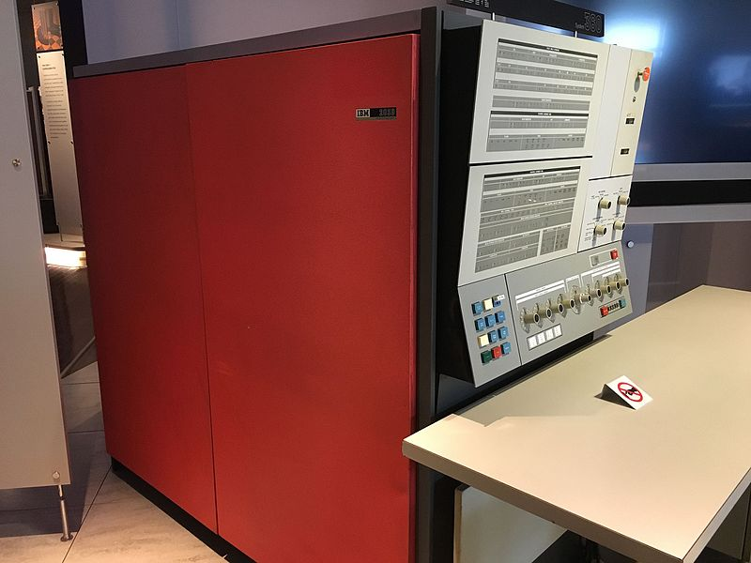

**PARTS OF THE SERVER**

* Cabinet
* Motherboard
* Microprocessor
* Heat Sink
* RAM
* Cooling Fans
* SMPS
* CABINET

The cabinet is the place where all the processing parts and drives are fixed.It is the place where all the components are to be fixed.

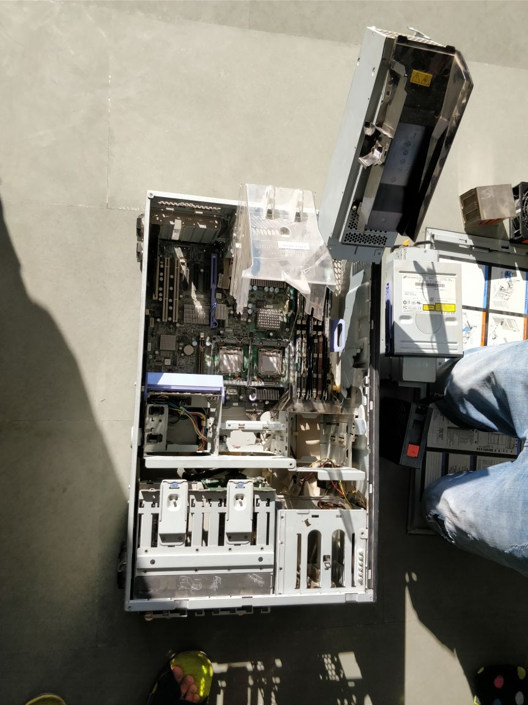

* MOTHERBOARD

The motherboard is the place where the processor,RAM,sound cards ,video cards,BIOS,etc are being placed.

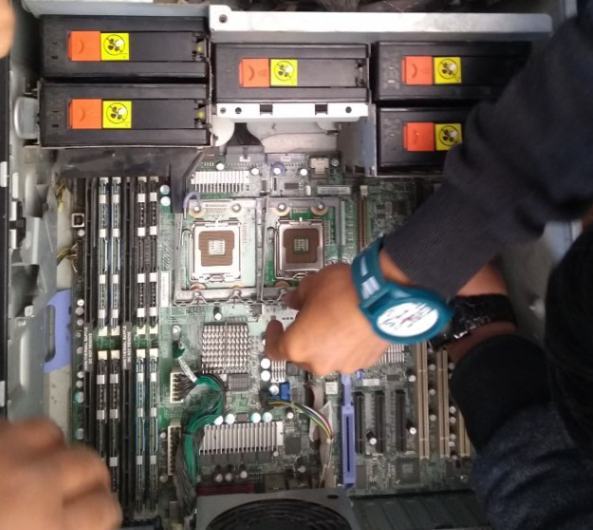

* HEAT SINK

A heat sink is an electronic [device](https://www.computerhope.com/jargon/d/device.htm) that incorporates a [fan](https://www.computerhope.com/jargon/f/fan.htm) to keep a hot component such as a [processor](https://www.computerhope.com/jargon/c/cpu.htm) cool.

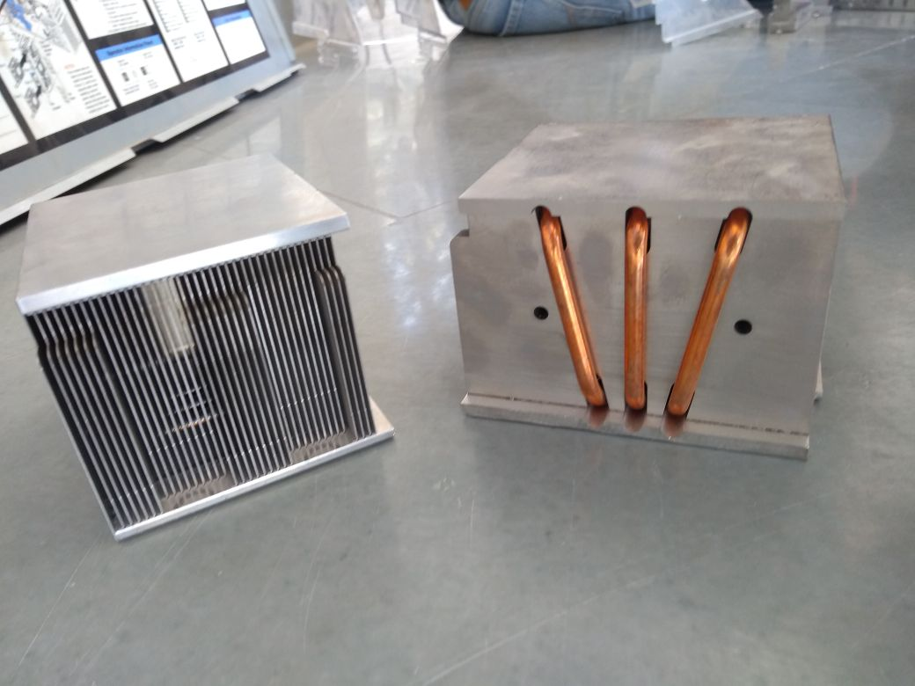

* MICROPROCESSOR

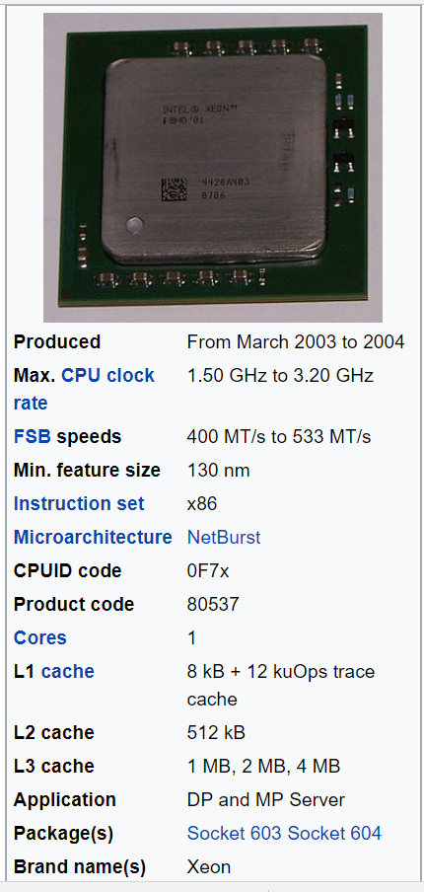A microprocessor, sometimes called a logic chip, is a computer processor on a microchip. The microprocessor contains all, or most of, the central processing unit (CPU) functions and is the "engine" that goes into motion when you turn your Computer on.

Basically the IBM motherboard contains 2 processor slots where intel xeon processors are installed.

* RAM

Random Access Memory, or RAM, usually refers to computer chips that temporarily store dynamic data to enhance computer performance while you are working. Random access memory is volatile, meaning it loses its contents once power is turned off.



This is a IBM ROHS RD MOD RAM.

* COOLING FANS

The cooling fans are the devices which makes the cabinet cool by removing the hot air from the cabinet.

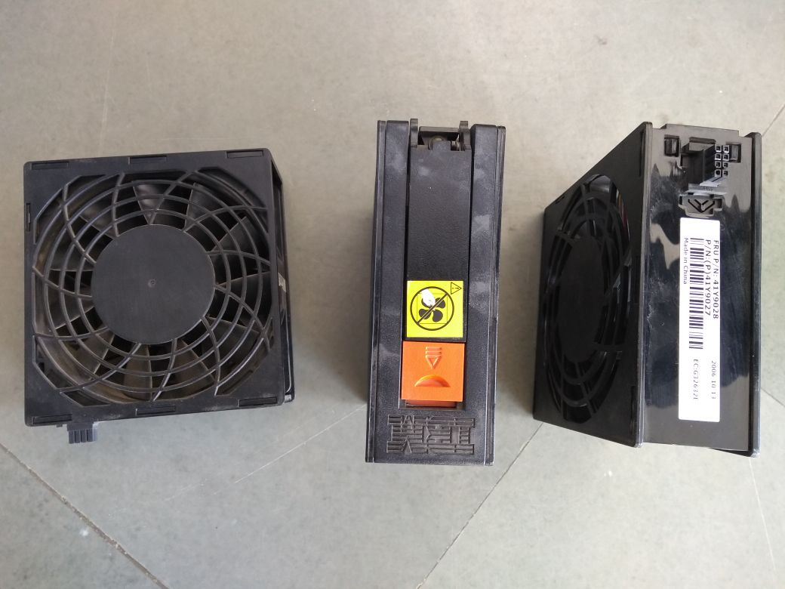

* SMPS

A switched-mode power supply (switching-mode power supply, switch-mode power supply, switched power supply, SMPS, or switcher) is an electronic [power supply](https://en.wikipedia.org/wiki/Power_supply) that incorporates a [switching regulator](https://en.wikipedia.org/wiki/Voltage_regulator#Switching_regulators) to [convert electrical power](https://en.wikipedia.org/wiki/Electrical_power_conversion) efficiently. Like other power supplies, an SMPS transfers power from a DC or AC source (often [mains power](https://en.wikipedia.org/wiki/Mains_electricity)) to DC loads, such as a [personal computer](https://en.wikipedia.org/wiki/Personal_computer), while converting voltage and current characteristics.

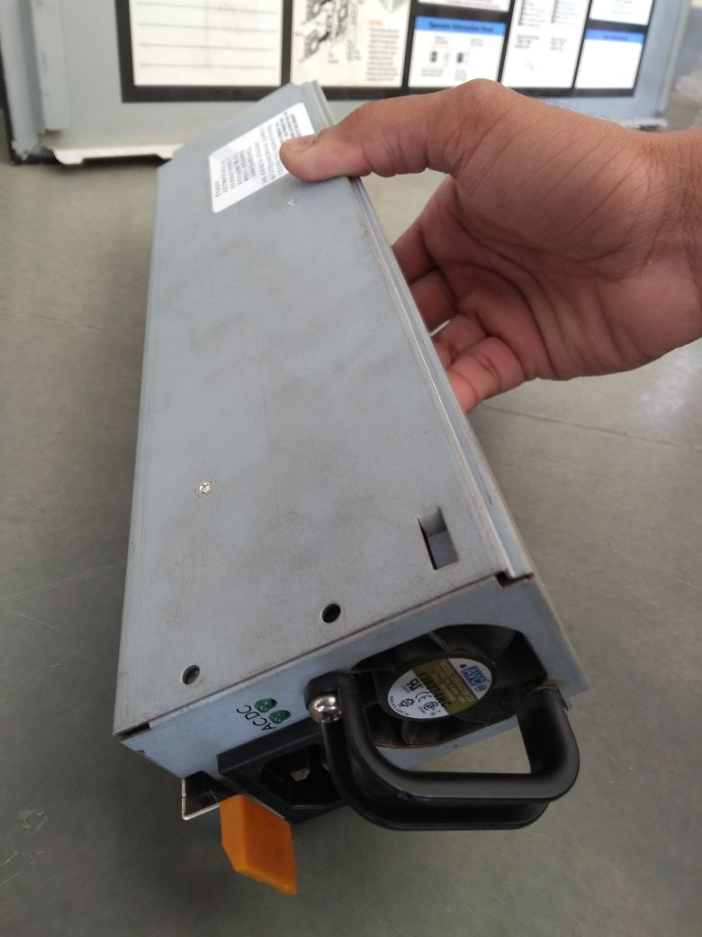

**STEPS TO ASSEMBLE THE SERVER**

Step 1:The assembling of the server is almost same as PC but here it is not the screwwork ,it is just the push functions taking place.

Step 2:Install the motherboard inside the cabinet.

Step 3:Install the 2 processors on the processor chipset board, such that it fits properly according to the position given in the cabinet.

Step 4:Install the heat sinks over the processor ,such that is fits exactly on the processor to remove the hot air from the processor.

Step 5: Insert the RAMs on the motherboard according to the noches so that they fit properly.

Step 6: Put all the 6 cooling fans at their places 1 on the left side and 5 in the center of the cabinet.

Step 7 :Put the two SMPS on the slot in the front side of the server and cover all the parts with the triangular plastic glass cases , and close the lid of the cabinet.

**PRACTICAL 2**

Aim : To study the working of HDD.

SOLUTION :

* What is HDD?

A hard disk drive (HDD), hard disk, hard drive or fixed disk is a [data storage device](https://en.wikipedia.org/wiki/Data_storage_device) that uses [magnetic storage](https://en.wikipedia.org/wiki/Magnetic_media) to store and retrieve [digital](https://en.wikipedia.org/wiki/Digital_data) information using one or more rigid rapidly rotating disks ([platters](https://en.wikipedia.org/wiki/Hard_disk_platter)) coated with magnetic material. The platters are paired with [magnetic heads](https://en.wikipedia.org/wiki/Disk_read-and-write_head), usually arranged on a moving [actuator](https://en.wikipedia.org/wiki/Actuator) arm, which read and write data to the platter surfaces. Data is accessed in a [random-access](https://en.wikipedia.org/wiki/Random-access) manner, meaning that individual [blocks](https://en.wikipedia.org/wiki/Block_(data_storage)) of data can be stored or retrieved in any order and not only [sequentially](https://en.wikipedia.org/wiki/Sequential_access). HDDs are a type of [non-volatile storage](https://en.wikipedia.org/wiki/Non-volatile_storage), retaining stored data even when powered off.

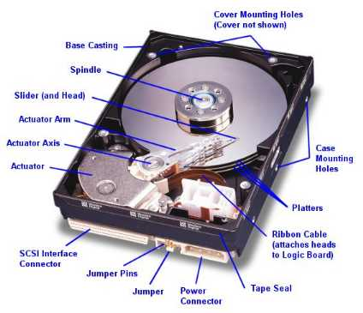 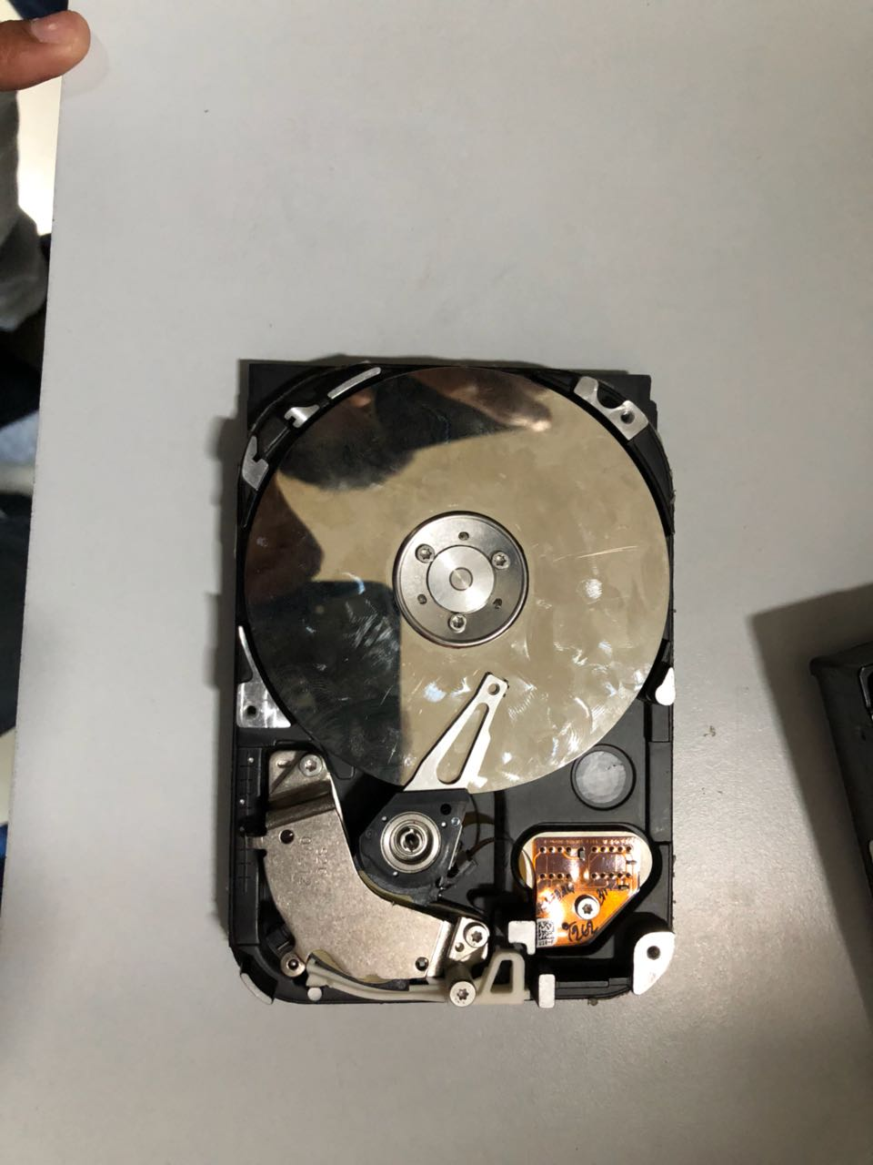

* PARTS OF HDD

1. PLATTER

The platters are the circular discs inside the hard drive where the 1s and 0s that make up your files are stored. Platters are made out of aluminum, glass or ceramic and have a magnetic surface in order to permanently store data. On larger hard drives, several platters are used to increase the overall capacity of the drive. Data is stored on the the platters in tracks, sectors and cylinders to keep it organized and easier to find.

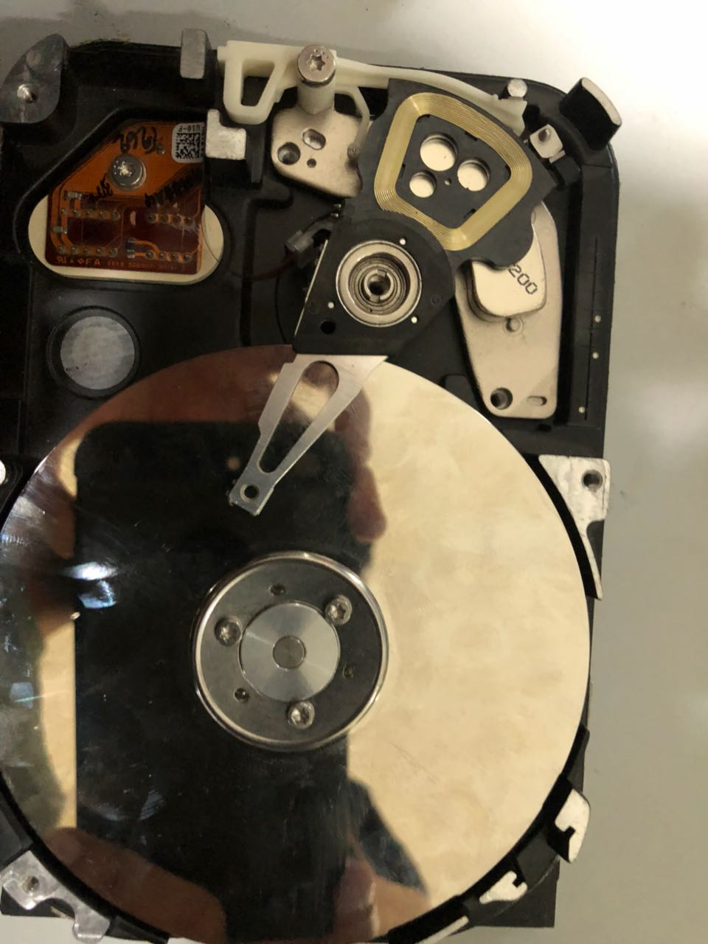

PLATTER

1. SPINDLE

The spindle keeps the platters in position and rotates them as required. The revolutions-per-minute rating determines how fast data can be written to and read from the hard drive. A typical internal desktop drive runs at 7,200 RPM, though faster and slower speeds are available. The spindle keeps the platters at a fixed distance apart from each other to enable the read/write arm to gain access.

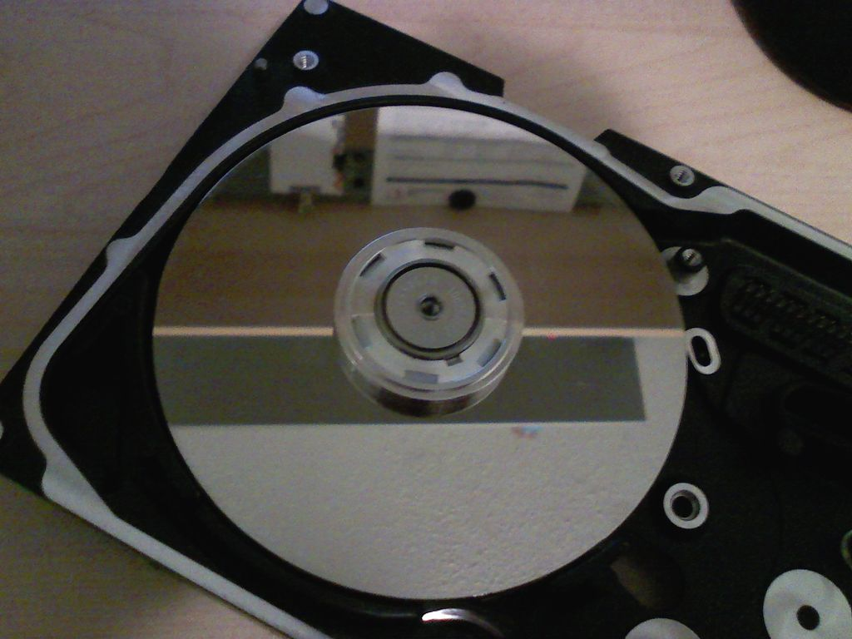

SPINDLE

1. READ/WRITE ARM (HEAD)

The read/write arm controls the movement of the read/write heads, which do the actual reading and writing on the disk platters by converting the magnetic surface into an electric current. The arm makes sure the heads are in the right position based on the data that needs to be accessed or written; it's also known as the head arm or actuator arm. There is typically one read/write head for every platter side, which floats 3 to 20 millionths of an inch above the platter surface.

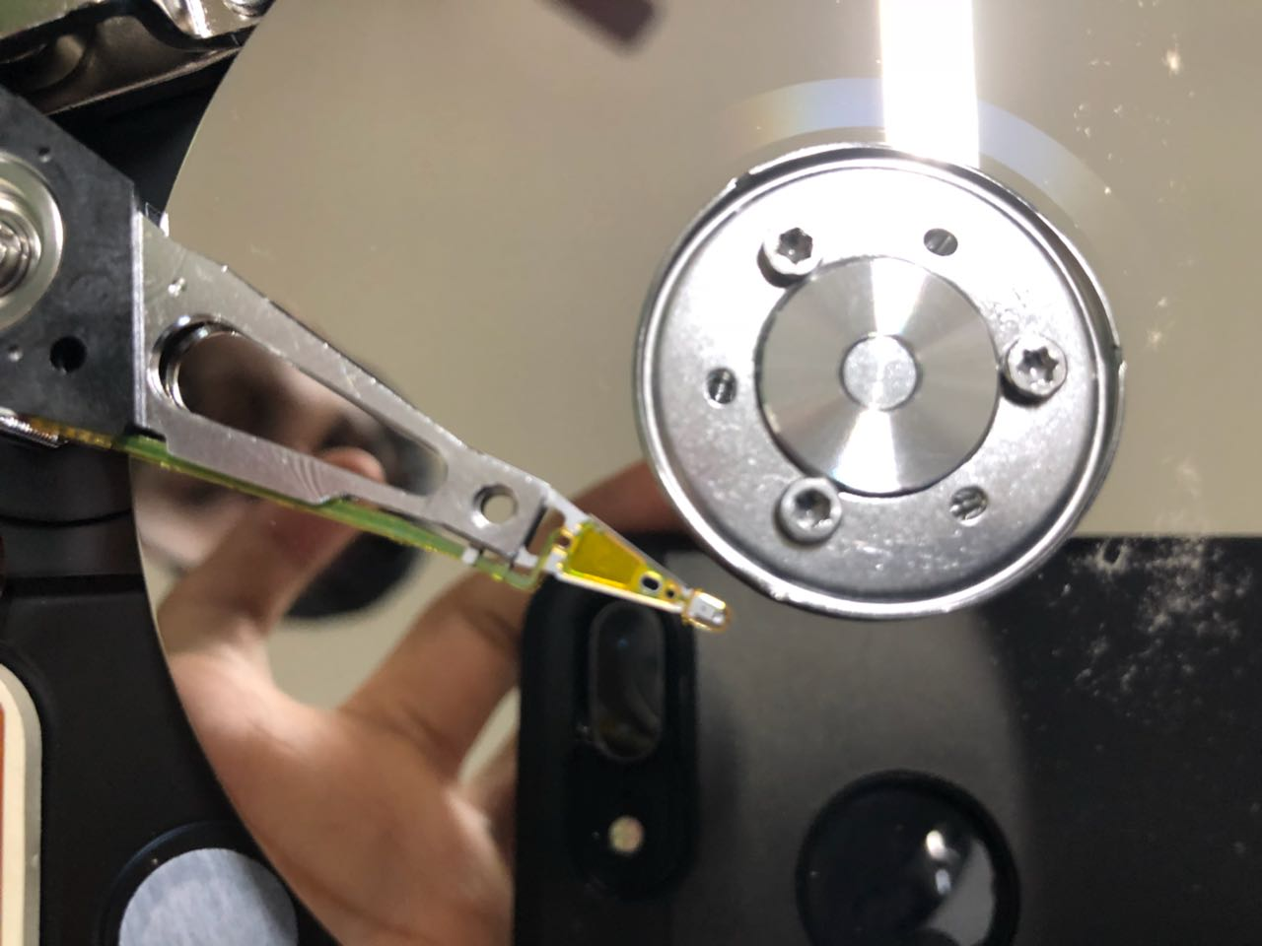

HEAD

1. ACTUATOR ARM

This arm is used to move the read heads in and out of the disk, so that data can be read and written to particular locations and you can access data in a Random fashion, you don't need to read your way through the entire disk to fetch a particular bit of information, you can jump right there. Seek time is very low.

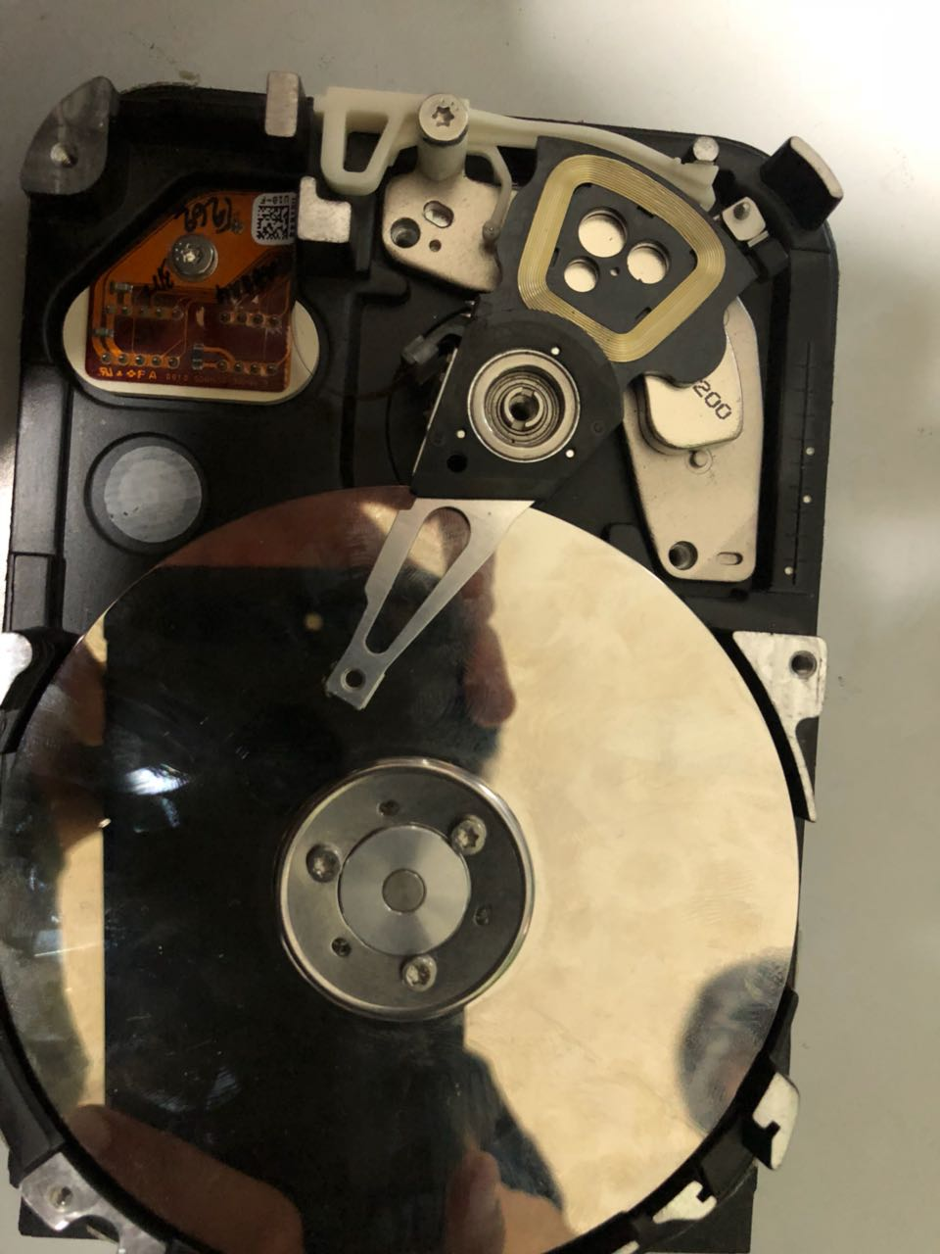

ACTUATOR ARM

1. POWER CONNECTOR AND IDE CONNECTOR

Power connector provides electricity to spin the platters, move the read head and run the electronics.

IDE connector allows for data transfer from and to the platters.

IDE CONNECTOR

POWER CONNECTOR

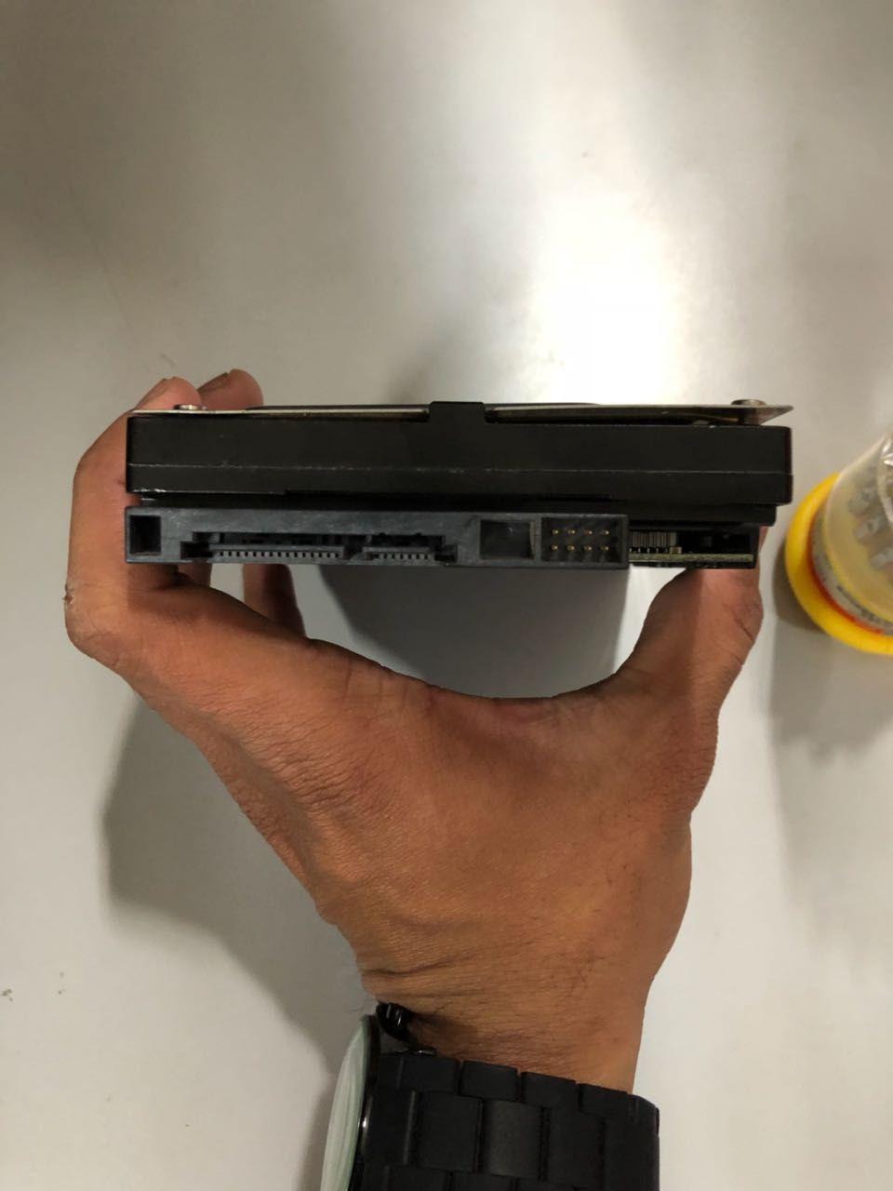

* HOW HARDDISK WORKS AND STORES THE DATA?

The platters spin around the spindle.

Data is requested to be read from a particular area of a platter.

The actuator arm moves the read head to that track.

Once the data sector that is required has spun around and under the read head, data is read.

Read data is sent from the IDE connector to main memory.

Writing data is very similar:

The platters spin around the spindle

Data is sent to the hard disk using the IDE connector

The actuator arm moves the write head to the track that will be written to

Once the data sector that is required has spun around and under the write head, data is written to the platter.

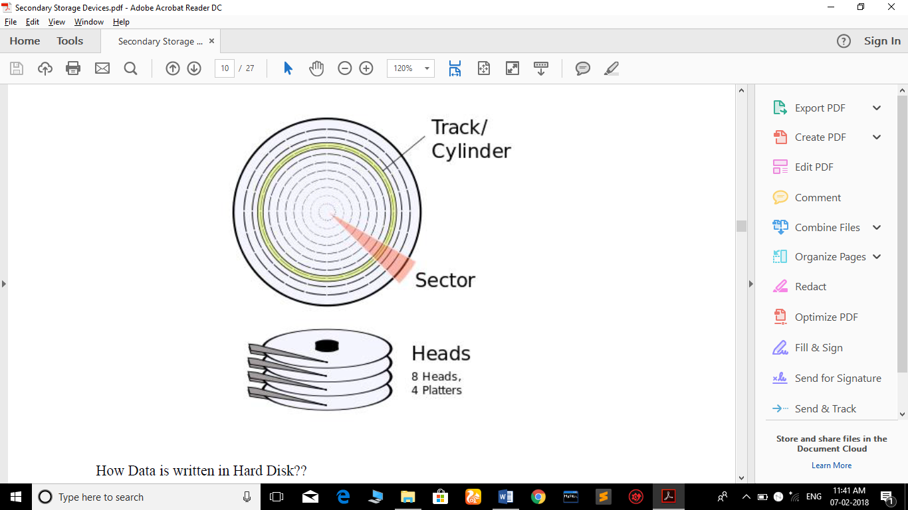

* SOLID STATE DRIVE(SSD)

A solid-state drive (SSD), or solid-state disk is a [solid-state storage](https://en.wikipedia.org/wiki/Solid-state_storage) device that uses [integrated circuit](https://en.wikipedia.org/wiki/Integrated_circuit) assemblies as [memory](https://en.wikipedia.org/wiki/Computer_storage) to store data [persistently](https://en.wikipedia.org/wiki/Persistence_(computer_science)). SSD technology primarily uses electronic interfaces compatible with traditional [block](https://en.wikipedia.org/wiki/Block_(data_storage)) input/output (I/O) [hard disk drives](https://en.wikipedia.org/wiki/Hard_disk_drive) (HDDs), which permit simple replacements in common applications. New I/O interfaces like [SATA Express](https://en.wikipedia.org/wiki/SATA_Express) and [M.2](https://en.wikipedia.org/wiki/M.2) have been designed to address specific requirements of the SSD technology.

SSDs have no moving mechanical components. This distinguishes them from traditional [electromechanical](https://en.wikipedia.org/wiki/Electromechanical) [magnetic disks](https://en.wikipedia.org/wiki/Magnetic_disk) such as [hard disk drives](https://en.wikipedia.org/wiki/Hard_disk_drive) (HDDs) or [floppy disks](https://en.wikipedia.org/wiki/Floppy_disk), which contain spinning [disks](https://en.wikipedia.org/wiki/Disk_storage) and movable [read/write heads](https://en.wikipedia.org/wiki/Disk_read-and-write_head).[[5]](https://en.wikipedia.org/wiki/Solid-state_drive#cite_note-STEC-5) Compared with electromechanical disks, SSDs are typically more resistant to physical shock, run silently, have quicker [access time](https://en.wikipedia.org/wiki/Access_time) and lower [latency](https://en.wikipedia.org/wiki/Latency_(engineering)). However, while the price of SSDs has continued to decline over time (24 cents per [gigabyte](https://en.wikipedia.org/wiki/Gigabyte) as of 2017), consumer-grade SSDs are (as of 2017) still roughly four times more expensive per unit of storage than consumer-grade HDDs.

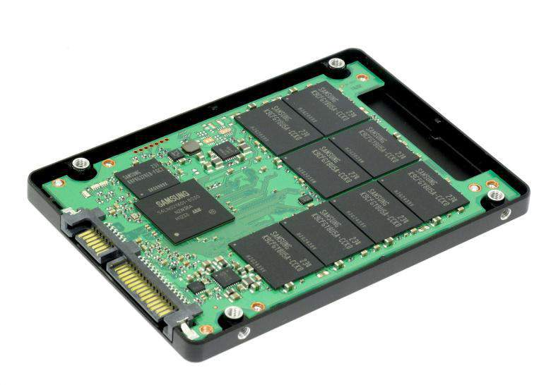 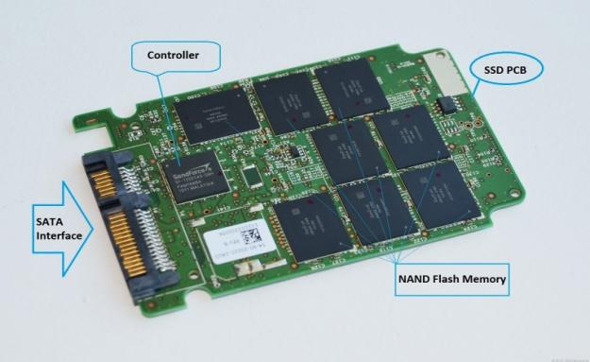

* **WHY SDD OVER HDD?**

SDD uses flash memory to store data, which provides better performance and reliability over an HDD. The HDD has moving parts and magnetic platters, meaning the more use they get, the faster they wear down and fail. With all the parts and requirements to spin the platters, the HDD uses more power than an SSD.

* HDD v/s SSD

|  |  |  |
| --- | --- | --- |
|  | **SSD** | **Hard Drive** |
| Definition | A solid-state drive is a data storage device that uses integrated circuit assemblies as memory to store data persistently. | A hard drive  is a non-volatile, random-access, magnetic data storage device |
| Invented | 1995 by M-Systems | 1956 by IBM |
| How data is stored | The data is stored in NAND-based flash memory. | Data is stored in a magnetic form on a thin film of ferromagnetic material on a disk. |
| Weight | Lighter compared to hard drives | Heavier compared to flash drives |
| Components | A small printed circuit board. These are protected inside a plastic, metal, or rubberized case. | HDD contains moving parts - a motor-driven spindle that holds one or more flat circular disks (called platters) coated with a thin layer of magnetic material. Read-and-write heads are positioned on top of the disks; all this is encased in a metal case. |
| Capacity | In 2011 SSDs were available in sizes up to 2 TB. | Up to 4 terabytes in external; internal up to 10 TB |
| Advantages | Little power, no fragile moving parts, smaller, lighter, data is impervious to mechanical shock, magnetic fields, scratches and dust. It does not require drivers to read and write | Portable, operates on plug and play basis, has more storage capacity, cheap, allows data stored in one place, faster data retrieval |
| Disadvantages | Highest is 256 GB for now, has a  limited number of write and erase cycles before the drive fails, easy to lose as they are small, can be used for viruses, more expensive, if the soldered tip breaks, the whole drive has to be replaced | Can fail, expensive to replace, heavier and bigger compared to other external storage devices, susceptible to damage by shock and vibration, does not work in high altitudes, strong magnetic fields wipe out data |
| Start-up time | Almost instantaneous; no mechanical components to prepare. May need a few milliseconds to come out of an automatic power-saving mode. | Disk spin-up may take several seconds. A system with many drives may need to stagger spin-up to limit peak power drawn, which is briefly high when an HDD is first started. |
| Random access time | Typically under 100 µs. | Ranges from 2.9 (high end server drive) to 12 milliseconds. |
| Read latency time | Low | Higher than SSD. |
| Data transfer rate | Consistent read/write speed, low performance. 100 MB/s to 600 MB/s | Around 140 MB/s. The rate depends on the rotational speed of head. |
| Consistent read performance | Yes | No |
| Fragmentation | There is limited benefit to reading data sequentially. | Yes large files are often fragmented. |
| Noise | SSDs have no moving parts and therefore are basically silent, although electric noise from the circuits may occur. | HDDs have moving parts (heads, actuator, and spindle motor) and make some sound. |
| Temperature control | Does not require any temperature cooling and can tolerate high temperatures. | High temperatures can shorten the life of the HD. |
| Susceptibility to environmental factors | No moving parts, very resistant to shock and vibration. | Heads floating above rapidly rotating platters are susceptible to shock and vibration. |
| Installation and mounting | Not sensitive to orientation, vibration, or shock. | Circuitry may be exposed, and must not contact metal parts. |
| Susceptibility to magnetic fields | No impact on flash memory | Magnets or magnetic surges could in principle damage data. |
| Reliability and lifetime | SSDs have no moving parts to fail mechanically. Each block of a flash-based SSD can only be erased (and therefore written) a limited number of times before it fails. | HDDs have moving parts, and are subject to potential mechanical failures from the resulting wear and tear. |
| Secure writing limitations | NAND flash memory cannot be overwritten, but has to be rewritten to previously erased blocks. If a software encryption program encrypts data already on the SSD, the overwritten data is still unsecured, unencrypted, and accessible (drive-based hardware encryption does not have this problem). Also data cannot be securely erased by overwriting the original file without special "Secure Erase" procedures built into the drive. | HDDs can overwrite data directly on the drive in any particular sector. However the drive's firmware may exchange damaged blocks with spare areas, so bits and pieces may still be present. |
| Cost per capacity | NAND flash SSDs cost approximately US$0.65 per GB | HDDs cost about US$0.05 per GB for 3.5 inch and $0.10 per GB for 2.5 inch drives. |
| Power consumption | High performance flash-based SSDs generally require half to a third of the power of HDDs. | The lowest-power HDDs (1.8" size) can use as little as 0.35 watts. |

* **SOME COMMON TERMS RELATED TO HDD:**

1. **TRACK:**

A track is a circular path on the surface of a disk or diskette on which information is magnetically recorded and from which recorded information is read. All information stored on a hard disk is recorded in [tracks](http://www.pcguide.com/ref/hdd/op/media_Tracks.htm), which are concentric circles placed on the surface of each platter, much like the annual rings of a tree. The tracks are numbered, starting from zero, starting at the outside of the platter and increasing as you go in. A modern hard disk has tens of thousands of tracks on each [platter](http://www.pcguide.com/ref/hdd/op/media.htm).

1. **SECTOR:**

In computer disk storage, a sector is a subdivision of a [track](https://en.wikipedia.org/wiki/Track_(disk_drive)) on a [magnetic disk](https://en.wikipedia.org/wiki/Magnetic_disk) or [optical disc](https://en.wikipedia.org/wiki/Optical_disc). Each sector stores a fixed amount of user-accessible data, traditionally 512 [bytes](https://en.wikipedia.org/wiki/Byte) for [hard disk drives](https://en.wikipedia.org/wiki/Hard_disk_drives) (HDDs).

The sector is the minimum storage unit of a hard drive. Most disk partitioning schemes are designed to have files occupy an integral number of sectors regardless of the file's actual size. Files that do not fill a whole sector will have the remainder of their last sector filled with zeroes. In practice, operating systems typically operate on [blocks of data](https://en.wikipedia.org/wiki/Block_(data_storage)), which may span multiple sectors.

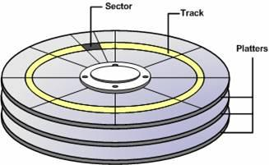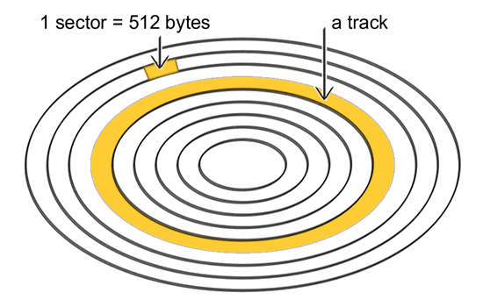

* **SEEK TIME:**

With rotating drives, the seek time measures the time it takes the head assembly on the actuator arm to travel to the track of the disk where the data will be read or written.

* **ROTATIONAL LATENCY:**

Rotational latency (sometimes called rotational delay or just latency) is the delay waiting for the [rotation](https://en.wikipedia.org/wiki/Rotation) of the disk to bring the required [disk sector](https://en.wikipedia.org/wiki/Disk_sector) under the read-write head.

* **FILE SYSTEMS:**
* **FAT:**

File Allocation Table(FAT) is a computer [file system](https://en.wikipedia.org/wiki/File_system) architecture and a family of industry-standard file systems utilizing it. The FAT file system is a legacy file system which is simple and robust. It offers good performance even in lightweight implementations, but cannot deliver the same performance, reliability and scalability as some modern file systems.

Different Types of FAT file systems:

1. FAT16
2. FAT32
3. exFAT
4. FAT+

* **NTFS:**

NTFS ("New Technology File System") is a [proprietary](https://en.wikipedia.org/wiki/Proprietary_software) [file system](https://en.wikipedia.org/wiki/File_system) developed by [Microsoft](https://en.wikipedia.org/wiki/Microsoft). Starting with [Windows NT 3.1](https://en.wikipedia.org/wiki/Windows_NT_3.1), it is the default file system of [Windows NT](https://en.wikipedia.org/wiki/Windows_NT) family.

NTFS has several technical improvements over the file systems that it superseded – [File Allocation Table](https://en.wikipedia.org/wiki/File_Allocation_Table) (FAT) and [High Performance File System](https://en.wikipedia.org/wiki/High_Performance_File_System) (HPFS) – such as improved support for [metadata](https://en.wikipedia.org/wiki/Metadata_(computing)) and advanced data structures to improve performance, reliability, and disk space use. Additional extensions are a more elaborate security system based on [access control lists](https://en.wikipedia.org/wiki/Access_control_list) (ACLs) and [file system journaling](https://en.wikipedia.org/wiki/Journaling_file_system).

* **DISK I/O:**

Disk I/O includes read or write or input/output operations (defined in KB/s) involving a physical disk. In simple words, it is the speed with which the data transfer takes place between the hard drive and RAM.

* **DISK FORMATTING:**

Disk formatting is the process of preparing a [data storage device](https://en.wikipedia.org/wiki/Data_storage_device) such as a [hard disk drive](https://en.wikipedia.org/wiki/Hard_disk_drive), [solid-state drive](https://en.wikipedia.org/wiki/Solid-state_drive), [floppy disk](https://en.wikipedia.org/wiki/Floppy_disk) or [USB flash drive](https://en.wikipedia.org/wiki/USB_flash_drive) for initial use. In some cases, the formatting operation may also create one or more new [file systems](https://en.wikipedia.org/wiki/File_system). The term "format" is understood to mean an operation in which a new disk medium is fully prepared to store [files](https://en.wikipedia.org/wiki/Computer_file).

This process is divided into 3 parts:

* 1. **Low Level Formatting:**

The first part of the formatting process that performs basic medium preparation is often referred to as "low-level formatting".

* 1. **Partitioning:**

[Partitioning](https://en.wikipedia.org/wiki/Disk_partitioning) is the common term for the second part of the process, making the data storage device visible to an [operating system](https://en.wikipedia.org/wiki/Operating_system).

* 1. **High Level Formatting:**

The third part of the process, usually termed "high-level formatting" most often refers to the process of generating a new file system. In some operating systems all or parts of these three processes can be combined or repeated at different levels.

**PRACTICAL 3**

AIM : Study different componenets of processors and how processors works.

* COMPONENTS OF PROCESSORS

**Arithmetic and Logic Unit (ALU)**

This is the brain of the microprocessor. The ALU performs basic arithmetic calculations like adding, subtracting, multiplication and division of figures, it also performs logical operations like comparison of figures.

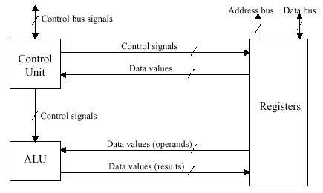

**Control Unit (CU)**

As the name suggests, this component **controls** all the functions that take place inside the processor itself. It instructs the ALU on which arithmetic and logical operation is to be performed. It acts under the direction of the system clock and sorts out all the internal data paths inside the processor to make sure that data gets from the right place and goes to the right place.

**Register**

Register also sometimes known as the accumulator, is a **temporary storage** position where data coming from RAM heading to the processor for execution and data coming from the processor after processing is held. Thus a register is a local storage area within the processor that is used to hold data that is being worked on by the processor.

**Internal Registers (Internal Data Bus)**

This is the [**bus**](https://turbofuture.com/computers/buses)connecting the internal components of the processor to the motherboard. The size of the internal registers indicates how much information the processor can operate on at one time and how it moves data around internally within the chip. This is sometimes also referred to as the internal data bus. A register is a holding cell within the processor; for instance, the processor can add numbers in two different registers, storing the result in a third register. The register size determines the size of data on which the processor can operate.

**External Data Path**

This is the path (bus) used to fetch data from memory to the processor. In some cases the internal and external data buses are the same bit-size but in others, the external data bus can be either narrower or wider. The external data path is normally not as wide as the internal data path.

Having a smaller external bus (data path) will slow the performance of the-CPU, but it makes it simpler to upgrade earlier system designs to a new processor. Having a larger external data bus will improve the performance as data can be brought into the CPU in large chunks.

**Address Lines**

The address lines are used to **specify** the exact location in memory where data can be found. The standard PC is a binary device. Using the memory address bus, CPUs send out location information on their address lines (or control lines) and these address lines are routed to every other major component of the computer (memory, ROM, expansion bus etc).

The numbers of address lines within the memory address bus will determine the maximum number of addressable locations. For example, if a PC has 3 address lines the maximum number of addressable memory locations is 8.